Assignment-10
B. Rishitha
192324130

1. Create a generic method sort List that takes a list of comparable elements and sorts it. Demonstrate this method with a list of Strings and a list of Integers.
Java code:
import java.util.List;
import java.util.ArrayList;
import java.util.Collections;

public class GenericSort {

public static <T extends Comparable<T>> void sortList(List<T> list) {
Collections.sort(list);
}

public static void main(String[] args) {
List<String> stringList = new ArrayList<>();
stringList.add("Banana");
stringList.add("Apple");
stringList.add("Cherry");

System.out.println("Before sorting: " + stringList);
sortList(stringList);
System.out.println("After sorting: " + stringList);

List<Integer> intList = new ArrayList<>();
intList.add(4);
intList.add(6);
intList.add(9);
intList.add(2);

System.out.println("Before sorting: " + intList);
sortList(intList);
System.out.println("After sorting: " + intList);
}
}
OUTPUT:
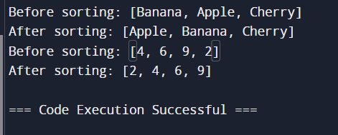
2. Write agenericclassTreeNoderepresentinganode ina tree withchildren. Implementmethodstoaddchildren, traversethetree (e.g.,depth-firstsearch),andfindanodebyvalue.Demonstratethis withatreeofStringsandIntegers.
Java code:
import java.util.ArrayList;
import java.util.List;

public class TreeNode {
private Integer value;
private List<TreeNode> children;

// Constructor to initialize the node with a value
public TreeNode(Integer value) {
this.value = value;
this.children = new ArrayList<>();
}

// Method to add a child node
public void addChild(TreeNode child) {
children.add(child);
}

// Method to get the value of the node
public Integer getValue() {
return value;
}

// Method to traverse the tree (DFS)
public void traverseDFS() {
System.out.println(value);
for (TreeNode child : children) {
child.traverseDFS();
}
}

// Method to find a node by value (DFS)
public TreeNode findNodeByValue(Integer value) {
if (this.value.equals(value)) {
return this;
}
for (TreeNode child : children) {
TreeNode result = child.findNodeByValue(value);
if (result != null) {
return result;
}
}
return null;
}

public static void main(String[] args) {
// Example usage with a tree of Integers
TreeNode root = new TreeNode(1);
TreeNode child1 = new TreeNode(2);
TreeNode child2 = new TreeNode(3);

root.addChild(child1);
root.addChild(child2);

System.out.println("Traversing tree of Integers:");
root.traverseDFS();

// Using the getValue() method
System.out.println("\nFinding '3': " + root.findNodeByValue(3).getValue());
}
}
OUTPUT:
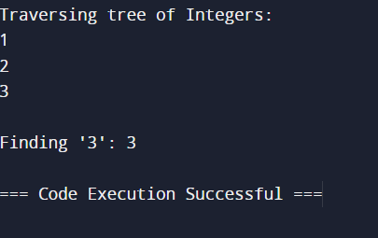
3. Implement a generic class GenericPriorityQueue>withmethods likeenqueue, dequeue, andpeek. The elements should be dequeued in priorityorder.Demonstrate withIntegerandString.
Java code:
import java.util.PriorityQueue;

public class GenericPriorityQueue<T extends Comparable<T>> {
private PriorityQueue<T> queue;

public GenericPriorityQueue() {
this.queue = new PriorityQueue<>();
}

public void enqueue(T element) {
queue.add(element);
}
public T dequeue() {
return queue.poll();
}
public T peek() {
return queue.peek();
}

public static void main(String[] args) {
GenericPriorityQueue<Integer> intQueue = new GenericPriorityQueue<>();
intQueue.enqueue(34);
intQueue.enqueue(7);
intQueue.enqueue(41);

System.out.println("Integer Queue - Peek: " + intQueue.peek());
System.out.println("Integer Queue - Dequeue: " + intQueue.dequeue());
System.out.println("Integer Queue - Dequeue: " + intQueue.dequeue());
GenericPriorityQueue<String> stringQueue = new GenericPriorityQueue<>();
stringQueue.enqueue("Banana");
stringQueue.enqueue("Apple");
stringQueue.enqueue("Cherry");

System.out.println("\nString Queue - Peek: " + stringQueue.peek());
System.out.println("String Queue - Dequeue: " + stringQueue.dequeue());
System.out.println("String Queue - Dequeue: " + stringQueue.dequeue());
}
}
OUTPUT:
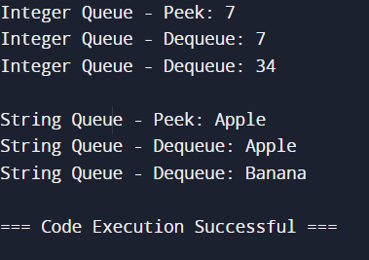
4. DesignagenericclassGraphwithmethods foraddingnodes, addingedges,andperforminggraphtraversals(e.g.,BFSandDFS). Ensure that the graph can handle both directed and undirected graphs.DemonstratewithagraphofStringnodesandanothergraph ofIntegernodes.
Java code:
import java.util.*;

public class Graph<T> {
private Map<T, List<T>> adjacencyList;
private boolean isDirected;

// Constructor to initialize the graph (directed or undirected)
public Graph(boolean isDirected) {
this.adjacencyList = new HashMap<>();
this.isDirected = isDirected;
}

// Method to add a node to the graph
public void addNode(T node) {
adjacencyList.putIfAbsent(node, new ArrayList<>());
}

// Method to add an edge between two nodes
public void addEdge(T source, T destination) {
adjacencyList.get(source).add(destination);
if (!isDirected) {
adjacencyList.get(destination).add(source);
}
}

// Method to perform Depth-First Search (DFS) traversal
public void dfs(T start) {
Set<T> visited = new HashSet<>();
dfsHelper(start, visited);
}

private void dfsHelper(T node, Set<T> visited) {
visited.add(node);
System.out.print(node + " ");
for (T neighbor : adjacencyList.get(node)) {
if (!visited.contains(neighbor)) {
dfsHelper(neighbor, visited);
}
}
}

// Method to perform Breadth-First Search (BFS) traversal
public void bfs(T start) {
Set<T> visited = new HashSet<>();
Queue<T> queue = new LinkedList<>();
queue.add(start);
visited.add(start);

while (!queue.isEmpty()) {
T node = queue.poll();
System.out.print(node + " ");
for (T neighbor : adjacencyList.get(node)) {
if (!visited.contains(neighbor)) {
visited.add(neighbor);
queue.add(neighbor);
}
}
}
}
public static void main(String[] args) {
// New example with a different String graph
Graph<String> stringGraph = new Graph<>(true); // directed graph
stringGraph.addNode("X");
stringGraph.addNode("Y");
stringGraph.addNode("Z");
stringGraph.addNode("W");
stringGraph.addEdge("X", "Y");
stringGraph.addEdge("X", "Z");
stringGraph.addEdge("Y", "W");
stringGraph.addEdge("Z", "W");

System.out.println("DFS Traversal (String Graph):");
stringGraph.dfs("X"); // Output: X Y W Z (or X Z W Y depending on edge order)

System.out.println("\nBFS Traversal (String Graph):");
stringGraph.bfs("X"); // Output: X Y Z W
}
}
OUTPUT:
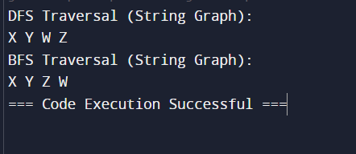
5. CreateagenericclassMatrixthat representsa matrix and supports operations like addition, subtraction, and multiplicationofmatrices.Ensure that theoperationsaretype-safe andefficient.DemonstratewithmatricesofIntegerandDouble.
Java code:
public class Matrix<T extends Number> {
private T[][] data;
private int rows;
private int columns;
public Matrix(int rows, int columns) {
this.rows = rows;
this.columns = columns;
this.data = (T[][]) new Number[rows][columns];
}
public void set(int row, int column, T value) {
data[row][column] = value;
}
public T get(int row, int column) {
return data[row][column];
}
public Matrix<T> add(Matrix<T> other) {
checkDimensions(other);
Matrix<T> result = new Matrix<>(rows, columns);
for (int i = 0; i < rows; i++) {
for (int j = 0; j < columns; j++) {
result.set(i, j, addValues(this.get(i, j), other.get(i, j)));
}
}
return result;
}
public Matrix<T> subtract(Matrix<T> other) {
checkDimensions(other);
Matrix<T> result = new Matrix<>(rows, columns);
for (int i = 0; i < rows; i++) {
for (int j = 0; j < columns; j++) {
result.set(i, j, subtractValues(this.get(i, j), other.get(i, j)));
}
}
return result;
}
public Matrix<Double> multiply(Matrix<T> other) {
if (this.columns != other.rows) {
throw new IllegalArgumentException("Matrix dimensions do not match for multiplication.");
}
Matrix<Double> result = new Matrix<>(this.rows, other.columns);
for (int i = 0; i < this.rows; i++) {
for (int j = 0; j < other.columns; j++) {
double sum = 0;
for (int k = 0; k < this.columns; k++) {
sum += this.get(i, k).doubleValue() * other.get(k, j).doubleValue();
}
result.set(i, j, sum);
}
}
return result;
}
private T addValues(T a, T b) {
if (a instanceof Integer) return (T) Integer.valueOf(a.intValue() + b.intValue());
if (a instanceof Double) return (T) Double.valueOf(a.doubleValue() + b.doubleValue());
throw new UnsupportedOperationException("Unsupported type for addition.");
}

private T subtractValues(T a, T b) {
if (a instanceof Integer) return (T) Integer.valueOf(a.intValue() - b.intValue());
if (a instanceof Double) return (T) Double.valueOf(a.doubleValue() - b.doubleValue());
throw new UnsupportedOperationException("Unsupported type for subtraction.");
}

private void checkDimensions(Matrix<T> other) {
if (this.rows != other.rows || this.columns != other.columns) {
throw new IllegalArgumentException("Matrix dimensions must match.");
}
}
public void print() {
for (int i = 0; i < rows; i++) {
for (int j = 0; j < columns; j++) {
System.out.print(get(i, j) + " ");
}
System.out.println();
}
}

public static void main(String[] args) {
Matrix<Integer> intMatrix1 = new Matrix<>(2, 2);
Matrix<Integer> intMatrix2 = new Matrix<>(2, 2);
intMatrix1.set(0, 0, 1); intMatrix1.set(0, 1, 2);
intMatrix1.set(1, 0, 3); intMatrix1.set(1, 1, 4);
intMatrix2.set(0, 0, 5); intMatrix2.set(0, 1, 6);
intMatrix2.set(1, 0, 7); intMatrix2.set(1, 1, 8);

System.out.println("Integer Matrix 1:");
intMatrix1.print();
System.out.println("Integer Matrix 2:");
intMatrix2.print();

Matrix<Integer> intSum = intMatrix1.add(intMatrix2);
System.out.println("Sum:");
intSum.print();

Matrix<Integer> intDiff = intMatrix1.subtract(intMatrix2);
System.out.println("Difference:");
intDiff.print();

Matrix<Double> intProduct = intMatrix1.multiply(intMatrix2);
System.out.println("Product:");
intProduct.print();
Matrix<Double> doubleMatrix1 = new Matrix<>(2, 2);
Matrix<Double> doubleMatrix2 = new Matrix<>(2, 2);
doubleMatrix1.set(0, 0, 1.5); doubleMatrix1.set(0, 1, 2.5);
doubleMatrix1.set(1, 0, 3.5); doubleMatrix1.set(1, 1, 4.5);
doubleMatrix2.set(0, 0, 5.5); doubleMatrix2.set(0, 1, 6.5);
doubleMatrix2.set(1, 0, 7.5); doubleMatrix2.set(1, 1, 8.5);

System.out.println("\nDouble Matrix 1:");
doubleMatrix1.print();
System.out.println("Double Matrix 2:");
doubleMatrix2.print();

Matrix<Double> doubleSum = doubleMatrix1.add(doubleMatrix2);
System.out.println("Sum:");
doubleSum.print();

Matrix<Double> doubleDiff = doubleMatrix1.subtract(doubleMatrix2);
System.out.println("Difference:");
doubleDiff.print();

Matrix<Double> doubleProduct = doubleMatrix1.multiply(doubleMatrix2);
System.out.println("Product:");
doubleProduct.print();
}
}
OUTPUT:
